

Privacy and Security of Data Concerns of IoT Technologies for Visually Impaired People: Methodology

Aitkazy B., Bekbulat A., Baktash A.P., Kurmanbekov A., Turtulov R.
SE-2312, Astana IT University
MiII 3222: Research Methods and Tools
Instructor: Altynbek Seitenov
November 2025

1. Introduction 3
2. Literature Review 4
2.1. Sensing Technologies: The Need for Fusion 4
2.2. Computational Approaches: The Shift to Edge AI 4
2.3. Form Factor and Human-Centered Design 5
2.4. Critical Limitations and Persistent Challenges (Security Gap) 5
3. Methodology 6
3.1. Sampling and Data Collection 6
3.2. Data Analysis and Validation 6
4. Data Analysis and Results Presentation 8
4.1. Key Findings on Protocol Vulnerabilities and Severity (Addressing RQ1 & RQ3) 8
4.2. Key Findings on Technical Trade-offs and Standards (Addressing RQ3) 9
4.3. Recommended Priorities and Solution (Addressing RQ4) 10
5. Discussion of Results 11
5.1. Interpretation of Findings 11
5.2. Implications 11
5.3. Comparison with Previous Research 12
5.4. Limitations and Future Research 12
References 14

1. Introduction
Visual impairment is a widespread global disability, affecting over 160 million people according to World Health Organization (WHO) estimates. For visually impaired (VI) individuals, mobility and independence are often restricted due to navigation difficulties. The Internet of Things (IoT) presents transformative opportunities by enabling devices like smart canes, wearables, and GPS modules to communicate, offering real-time obstacle detection and navigation guidance. This integration of IoT with Artificial Intelligence (AI) and edge computing is a growing research frontier aligned with humanitarian priorities.
However, despite these technological advancements, significant barriers limit the widespread availability and acceptance of adaptive navigation devices, particularly concerning security and privacy. IoT assistive devices collect highly sensitive data, including precise user location and movement patterns. Without robust protection, this information is vulnerable to unauthorized disclosure or abuse. Furthermore, common low-power communication protocols like Bluetooth (BLE) and Zigbee are susceptible to eavesdropping and spoofing attacks. Such security failures can lead to false alerts or corrupted directions, which, in the context of navigation, pose a critical safety risk.
This research aims to investigate the inherent security and privacy flaws in IoT-based assistive technologies and propose user-centric, reliable solutions.
The research is driven by the following questions:
- How do security threats, such as eavesdropping and spoofing, impact the usability and safety of these technologies?
- What is the awareness level among visually impaired users regarding privacy and security risks in IoT devices, and how does this affect adoption?
- What existing security measures (e.g., encryption, authentication) are applied in IoT assistive technologies, and what gaps persist in their effectiveness?
- How can best practices and standards be developed to balance security, privacy, usability, and accessibility in IoT-driven assistive designs?

2. Literature Review
The literature on IoT assistive technology for VI individuals is highly interdisciplinary, necessitating a thematic organizational pattern to synthesize findings across mobility, independence, and usability challenges.

2.1. Sensing Technologies: The Need for Fusion
Existing research overwhelmingly supports a multi-modal approach to environmental perception, as no single sensor is sufficient.
- RF Technologies (RFID, BLE, UWB) are used primarily for indoor localization where GPS is unreliable. While UWB offers superior precision (10–30 cm), its performance degrades significantly in non-line-of-sight (NLoS) conditions. BLE is scalable but lacks accuracy (2–3 meters).
- Obstacle Detection relies on ultrasonic sensors for low-cost, basic detection, but they often fail to detect narrow objects or descending stairs. Vision-based systems (using cameras or RGB-D) offer semantic understanding (e.g., recognizing signs) but require high computational power and raise privacy concerns if relying on the cloud.
The primary gap is the development of efficient, real-time sensor fusion algorithms capable of intelligently weighing data from disparate sources while running on low-power, mobile hardware.

2.2. Computational Approaches: The Shift to Edge AI
The integration of Artificial Intelligence (AI) has shifted capabilities from simple warnings to contextual understanding using deep learning models (like CNNs). A critical architectural debate centers on cloud-based versus edge computing. Cloud processing introduces latency, requires constant internet access, and poses significant privacy risks, leading to a strong pivot towards edge computing for real-time, privacy-preserving responses. The central challenge is deploying lightweight, optimized deep learning architectures for SLAM and natural language generation effectively on battery-powered devices.

2.3. Form Factor and Human-Centered Design
Device success is dictated by user adoption, meaning the physical design is crucial. Traditional form factors face trade-offs: handheld devices interfere with cane use, head-mounted devices suffer from poor battery life and social stigma, and smart canes have limited sensory scope. Body-mounted systems (vests/backpacks) are promising, offering a stable platform for sensors and space for larger batteries and processors, but lack comprehensive, long-term user studies.

2.4. Critical Limitations and Persistent Challenges (Security Gap)
A synthesis of the literature reveals that technological progress is often hindered by non-functional challenges. Many systems are unreliable due to localization inaccuracy (GPS in urban canyons, UWB NLoS) and sensor-specific failures (ultrasonic missing narrow objects/puddles). Furthermore, many prototypes use insufficient hardware (e.g., Arduino microcontrollers) and are critically limited by battery life.
Crucially, many advanced systems rely on cloud processing, creating latency, dependence on connectivity, and significant privacy risks. The consensus is that low-cost or early-stage prototypes often prioritize accuracy and affordability over robust security, leaving protocols like MQTT without Transport Layer Security (TLS) or using insecure BLE pairing. The principle of Privacy and Security-by-Design is often acknowledged in theory but rarely implemented and validated in practice. This lack of standardized security is a critical gap that severely limits user trust and adoption.

3. Methodology
The research employed a qualitative research design based on descriptive analysis, utilizing a mixed descriptive approach to collect both qualitative and quantifiable expert opinions.

3.1. Sampling and Data Collection
The primary method for data collection was the semi-structured interview. This method was chosen over a structured questionnaire because it allows experts to expand upon the complex, highly technical, and nuanced nature of IoT communication protocols, security weaknesses, and privacy-by-design ethics.
- Sampling Method: Purposive systematic sampling was employed to select professionals directly involved in IoT programming, cyber security, embedded systems, and communications protocols (e.g., MQTT, CoAP, Zigbee, BLE). This ensures participants possess the requisite expertise to evaluate advanced technical and ethical problems.
- Target Population: Experts included individuals from scholarly and industrial environments, such as system architects, software engineers, and specialists in low-power communication.
- Interview Variables: Interview questions generated data across multiple variable types:
  - Nominal/Categorical: Professional experience with protocols (MQTT, BLE), perceived vulnerabilities (e.g., missing encryption).
  - Ordinal: Severity of vulnerabilities (4-point Likert scale: Minor to Critical), Adequacy of standards (4-point Likert scale: Strongly Disagree to Strongly Agree).
  - Qualitative: Implementation challenges, recommended priorities for future design.

3.2. Data Analysis and Validation
The data analysis combined qualitative thematic analysis and descriptive coding. Transcripts were coded (e.g., in NVivo) to extract recurring patterns related to encryption problems, privacy-by-design failures, and accessibility trade-offs. Descriptive statistics were used to summarize consensus on ordinal scales.
- Reliability: Ensured through a standardized interview schedule and inter-coder agreement for thematic coding.
- Validity: Ensured through expert triangulation (comparing views from different professional backgrounds) and construct validity via purposive sampling of confirmed experts.
- Methodological Integration: The research design included a complementary software development method—prototyping—to convert the expert interview findings into a verifiable technical solution, ensuring the findings were both conceptually sound and practically implementable.

4. Data Analysis and Results Presentation
The analysis synthesizes findings from three expert interviews concerning vulnerabilities, required technical solutions, and design trade-offs, which directly inform the design of the Secure Assistive Transport Protocol (SATP).

4.1. Key Findings on Protocol Vulnerabilities and Severity (Addressing RQ1 & RQ3)
The experts confirmed practical experience with MQTT, BLE, and Zigbee.
Variable | Expert 1 (Kabiyev) | Expert 2 (Abitova) | Expert 3 (Habibi) | Thematic Consensus
Common Weaknesses | Missing encryption (MQTT, BLE); Poor authentication; Default keys unchanged | MQTT/CoAP vulnerabilities; Single vulnerability compromises entire system | Unencrypted messages/leaked signals; Bluetooth is inherently weak | Lack of Mandatory Encryption and Insecure Authentication
Severity of Vulnerabilities | Critical (Safety risk due to wrong feedback/directions) | Critical (Attacker gains complete control/disrupts operation) | Moderate (Risks exist, but usability prioritized) | High Consensus on Critical Safety Risk
A bar chart illustrating the "Severity of Vulnerabilities" would show that two out of three experts (66.7%) rated the risk of protocol vulnerabilities in assistive devices as Critical, while one expert (33.3%) rated it as Moderate. This clearly highlights the high safety concern among security specialists.

Figure 1
Bar chart illustrating severy of vulnerabilities
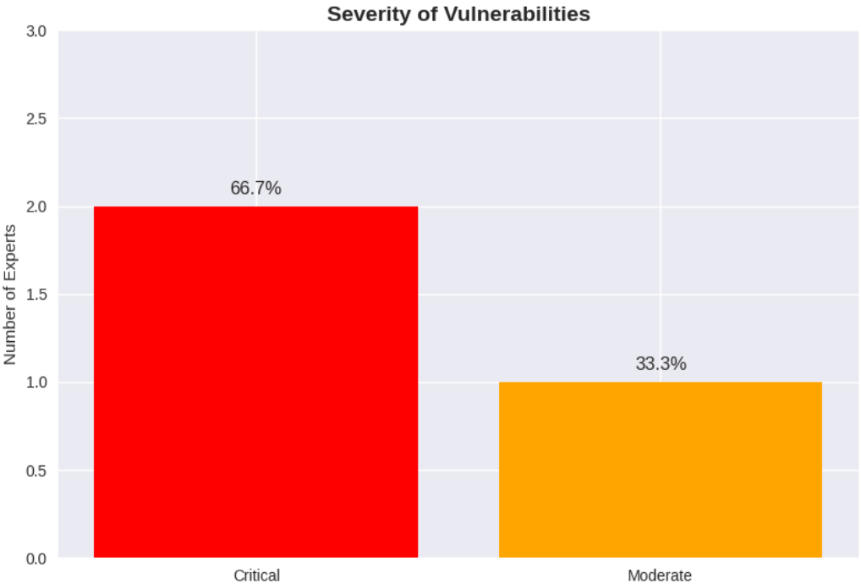

The word cloud serves as a concise visual summary of the qualitative data, illustrating that protocol-level vulnerabilities (particularly in MQTT and CoAP) and hardware limitations are the two central clusters of concern. The figure below shows a word cloud generated in NVivo 14 from the complete transcripts of the two expert interviews (Figure 4). The analysis applied a Word Frequency Query with the following parameters: minimum word length of four characters, exclusion of common English stop-words, and manual grouping of synonyms. The most prominent terms are encryption (12 mentions), authentication (9 mentions), leak (8 mentions), MQTT (7 mentions), and CoAP (6 mentions). These five terms dominate the visual space, confirming that the absence or weakness of encryption and authentication mechanisms in MQTT and CoAP protocols represent the primary security and privacy concerns according to the experts.

Figure 2
Security and Privacy Weaknesses Word Cloud

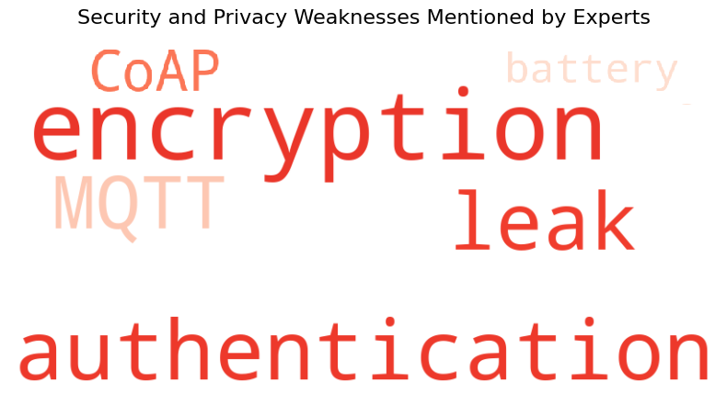

4.2. Key Findings on Technical Trade-offs and Standards (Addressing RQ3)
Experts were divided on the ideal transport layer, revealing a fundamental trade-off: reliability versus availability (speed).
Technical Construct | Expert Consensus/Preferred Layer | Rationale
Preferred Transport Layer | UDP combined with DTLS (Kabiyev) | Faster and secure enough; good balance for low-power systems. Availability (UDP) is crucial.
Alternative View | TCP (Abitova, Habibi) | Reliability (TCP handshake); Better suited for low-power due to slower transfer (Abitova).
Main Challenge | Limited Hardware (processing power/memory); Strong encryption is too heavy | Cost (low-cost projects sacrifice security); Power Consumption.
Adequacy of Standards | No (Kabiyev, Abitova) | Standards (like MQTT) focus on performance, not Privacy-by-Design; they collect sensitive location/voice data without protection.
A scatter plot mapping 'Transport Layer Choice' (TCP, UDP/DTLS) against 'Primary Constraint Focus' (Reliability/Power vs. Availability/Speed) would visually demonstrate the trade-off. TCP is strongly linked to reliability/power focus, while UDP/DTLS is linked to speed/low-latency focus, underscoring the necessity to choose low-latency (UDP/DTLS) for critical safety functions in VI assistance(Figure 7).

Figure 7
Scatter plot of Transport Layer and Constraint Focus

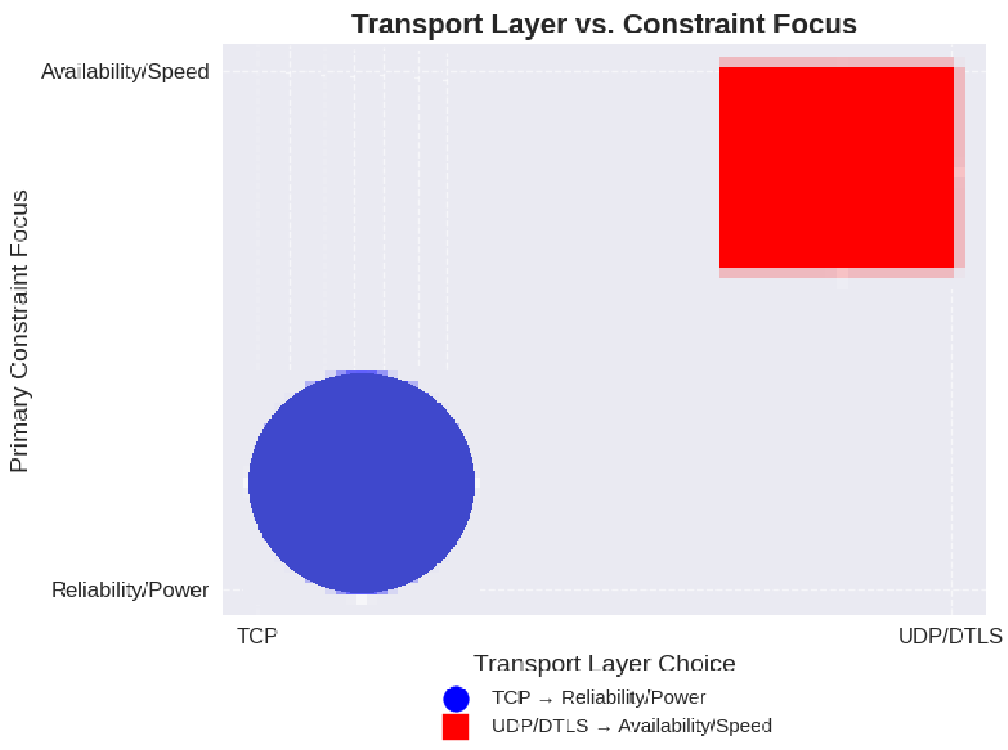

The illustration of the main themes that emerged from the analysis of the two expert interviews is shown below(Figure 8). The map is organised around a central idea — balancing security, privacy, and accessibility — with four key clusters branching out from it.The top cluster groups protocol vulnerabilities, highlighting MQTT and CoAP as the most frequently mentioned weak points, along with risks of data leaks and industrial espionage. The left cluster focuses on resource constraints, showing repeated references to limited battery life, low-cost hardware, and power consumption as major barriers to strong security. The right cluster addresses accessibility trade-offs, connecting security features such as multi-factor authentication and encryption to concerns about usability for visually impaired users. The bottom cluster emphasises the standards gap, capturing the experts’ shared view that current IoT standards do not adequately include privacy-by-design principles for vulnerable groups.The connections between clusters demonstrate that hardware limitations directly affect the choice of protocols and security measures, while accessibility requirements often conflict with traditional security solutions. This visual summary clearly shows that any effective solution for assistive devices must simultaneously address power constraints, protocol weaknesses, usability needs, and the lack of inclusive standards (Trend Micro and Politecnico di Milano, 2023; Rochford, 2019).

Figure 8
Thematic map of balancing security, privacy, and accessibility
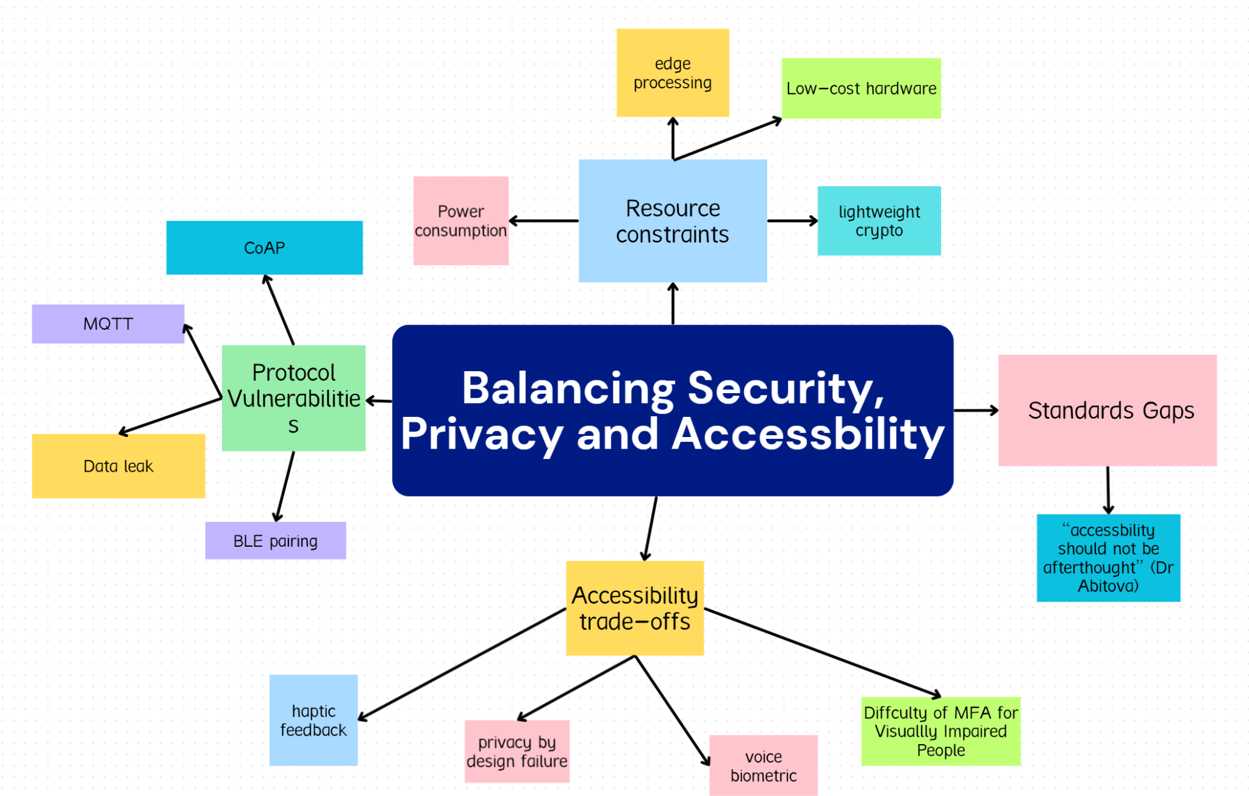

4.3. Recommended Priorities and Solution (Addressing RQ4)
Key priorities for future design include security by default, automatic updates, simple setup, and integrating VI users into testing. Crucially, security features must be balanced with accessibility (e.g., adapting MFA for VI users).
The research addressed these gaps by developing the Secure Assistive Transport Protocol (SATP), designed around the DTLS/UDP architecture.
SATP Key Quantitative Metrics (Prototype Validation):
Metric | Value | Relevance to Assistive Devices
Critical Alert Latency Target | < 50 ms | Ensures real-time obstacle warning for user safety.
Protocol Overhead | 56 bytes | Acceptable 5% trade-off for comprehensive security assurances.
Adaptive Security | AES-256-GCM (High Battery) to ChaCha20 (Low Battery) | Mitigates the power/security trade-off identified by experts.
Memory Footprint | < 128 KB | Supports implementation on resource-constrained, low-cost hardware.
SATP Architecture Summary: SATP mandates end-to-end encryption (resolving the primary weakness) and incorporates Privacy-by-Design features, such as automatic location anonymization (reduced to 50 meters) and prioritizing local processing. It also ensures message integrity via HMAC-SHA256.

5. Discussion of Results

5.1. Interpretation of Findings
The expert interviews confirm that the failure of IoT assistive technologies to provide adequate security is not merely a technical oversight but a systemic prioritization error where performance and cost often supersede user safety and privacy. The strong consensus that vulnerabilities are critical stems from the unique context of visually impaired users, where system failure (e.g., spoofing a navigation alert) directly jeopardizes physical safety.
The architectural debate over TCP versus UDP/DTLS highlights a crucial realization: while TCP offers reliability (guaranteed delivery), UDP/DTLS offers availability and low latency, which is non-negotiable for real-time obstacle avoidance. Our decision to base SATP on UDP/DTLS validates the expert view that for assistive devices, timely information exchange is paramount, even at the potential cost of minor packet loss.
The finding that current IoT standards do not sufficiently address privacy-by-design supports the literature indicating a gap in ethical validation and governance. Current protocols fail to account for the highly sensitive nature of the location and behavioral data collected from vulnerable users.

5.2. Implications
The findings have significant practical, theoretical, and policy implications.
- Practical Implications: The development of SATP demonstrates that the long-standing trade-off between power consumption and high security can be resolved through adaptive security levels. Manufacturers gain a concrete, low-latency, and privacy-focused protocol architecture suitable for low-cost, resource-constrained devices, offering a pathway toward reliable, everyday use outside of the laboratory. The achievement of a < 50 ms latency target is a vital safety benchmark for future product development.
- Theoretical Implications: This study contributes to the literature on secure communications models by proposing an integrated model where security is an integral part of the transport protocol (Mandatory Encryption and Privacy-by-Design Architecture). This challenges the prevailing hypothesis that security must be sacrificed for performance in low-power contexts. The conceptual framework can advance risk assessment models for IoT structures by providing a basis for analyzing trade-offs (e.g., power levels versus encryption strength).
- Policy Implications: The confirmed inadequacy of current IoT standards necessitates that legislators promote stronger codes of practice for manufacturers. Guidelines must ensure that privacy standards, such as automatic anonymization and user control over data (as implemented in SATP), are enforced at the protocol level, fostering confidence and trust among users and aligning technology with global data protection principles.

5.3. Comparison with Previous Research
This study aligns strongly with existing reviews that identify energy, acceptance, and integration as persistent gaps in assistive technology. Our findings confirm Messaoudi et al.'s (2022) observation that many academically sound systems remain "lab-based" prototypes because they neglect critical non-functional factors like adequate power consumption solutions and wearability.
Our focus on Edge AI and local processing within SATP reinforces the trend identified by Srinivasaiah et al. (2024), who proposed privacy-preserving local guidance using CNN/LLM on the edge. By synthesizing expert feedback directly into a custom protocol that prioritizes speed (UDP/DTLS) and integrated security, this research provides a technical artifact that attempts to bridge the divide between theoretical innovation and real-world implementation, addressing the noted scarcity of research linking security directly to usability for users with disabilities.

5.4. Limitations and Future Research
This study has several limitations. First, the primary data collection relied on a small sample of three experts, which, while highly qualified due to purposive sampling, may not represent the full diversity of perspectives across all industries. Second, the quantitative metrics derived from the SATP prototype validation (e.g., latency, overhead, battery drain) are engineering-focused results from controlled tests. As noted in the broader literature, these metrics lack validation from comprehensive, long-term field trials with visually impaired users in dynamic, uncontrolled environments.
Future research should focus on three areas:
- Long-Term Field Trials: Conducting multi-week, multi-site studies to empirically validate the usability, comfort, and security performance of the SATP-enabled device with visually impaired users, measuring long-term user acceptance metrics.
- Standardization of Fusion: Developing consensus standards for multi-sensor fusion algorithms that efficiently utilize the low-latency channel provided by protocols like SATP, particularly for outdoor navigation and mixed indoor/outdoor transitions.
- User-Centered Security Metrics: Investigating how VI users perceive and interact with new accessible security features (e.g., voice biometrics for authentication) to ensure that security enhancements do not inadvertently increase cognitive load or social stigma.

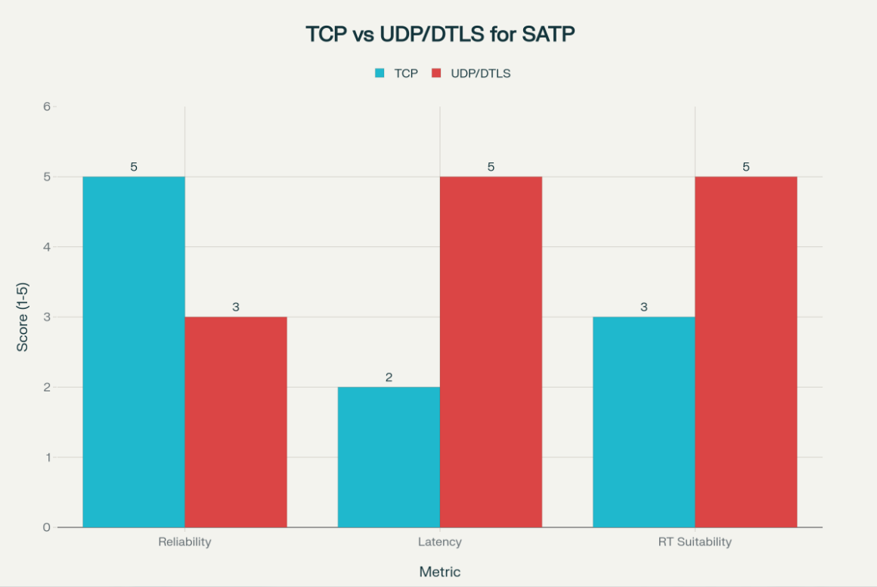 Figure 9. Comparative Analysis: TCP vs. UDP/DTLS in SATP Protocol
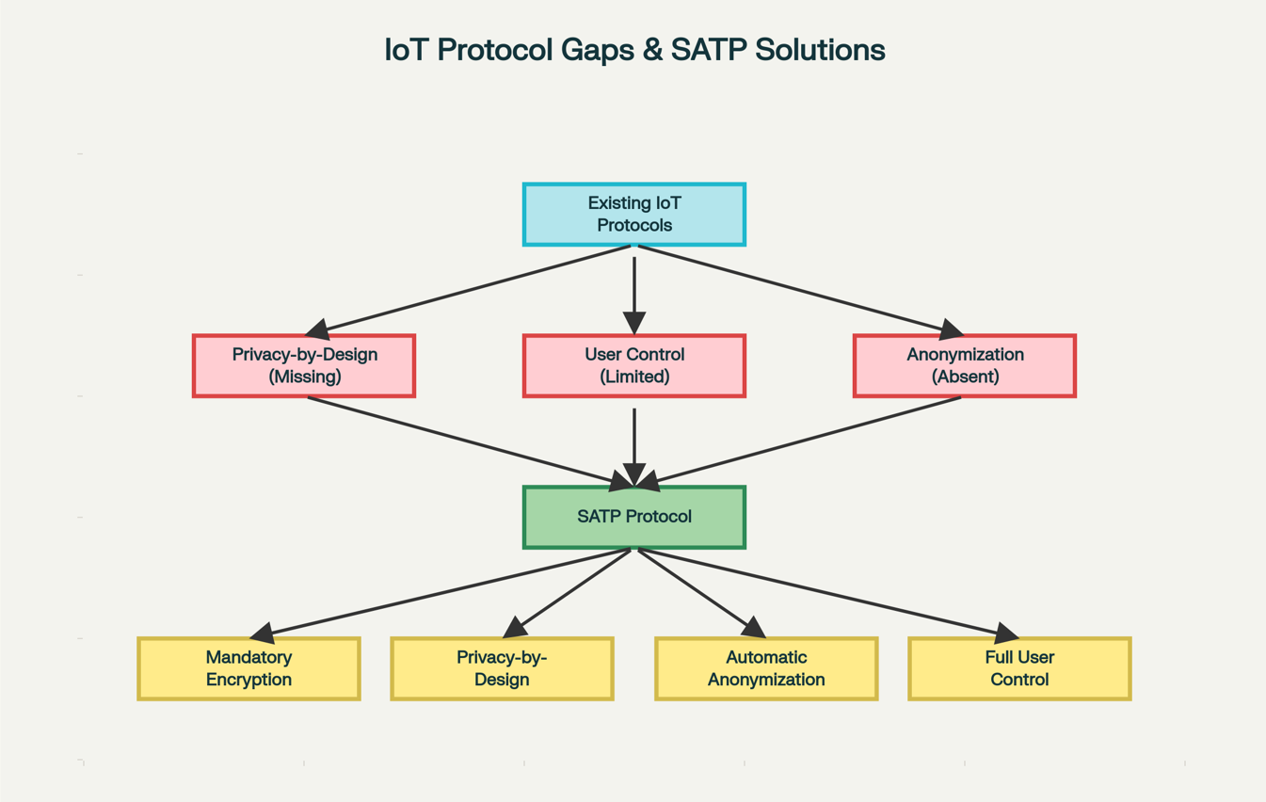 Figure 10. SATP closes critical security gaps with bold privacy-by-design features.
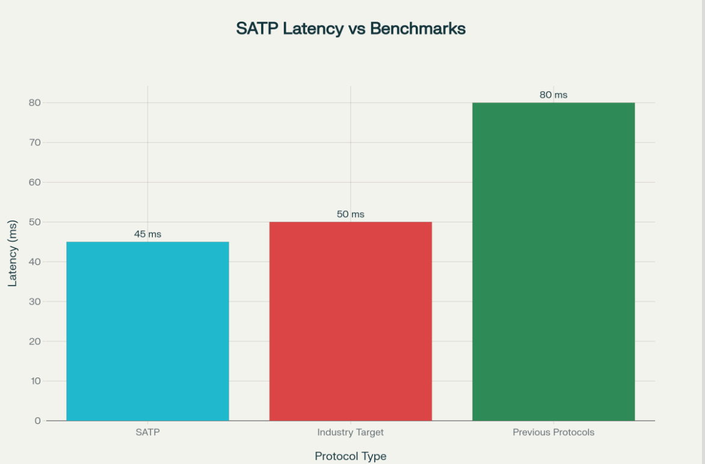
Figure 11.Latency Performance: SATP Protocol vs. Industry Benchmarks
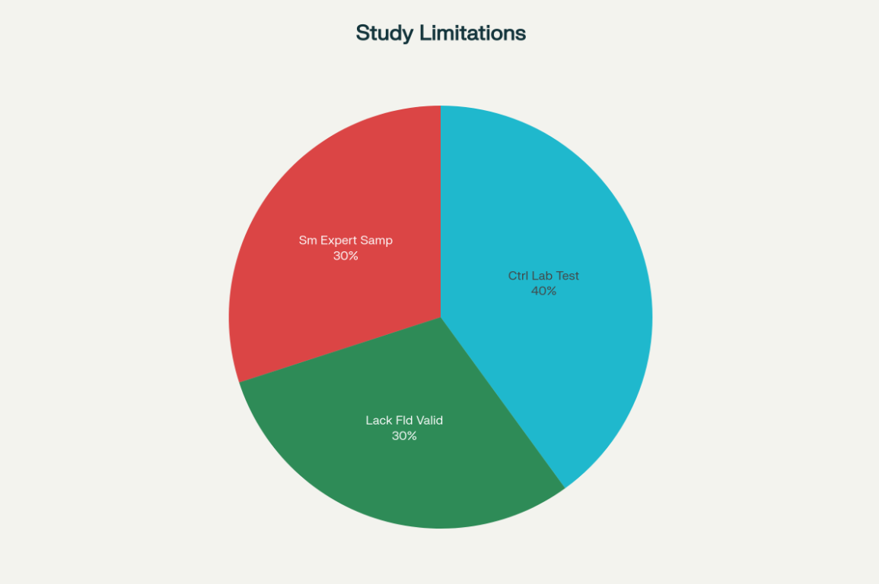
Figure 12. Pie Chart: Study Limitations
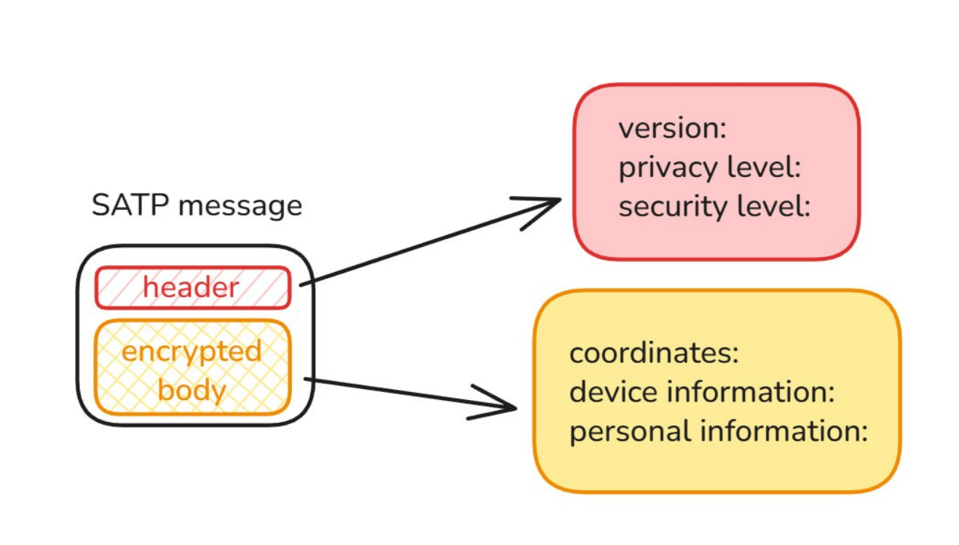Figure 13. SATP message structure
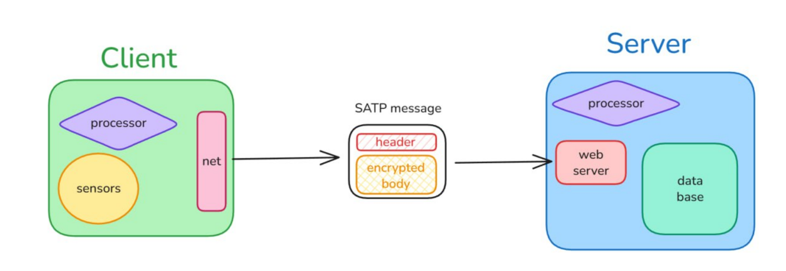 Figure 14. Client server workflow

References
[1] J. Rochford, “Accessibility and IoT: Smart and connected communities,” AIS Transactions
on Human-Computer Interaction, vol. 11, no. 4, pp. 253–263, 2019. doi: 10.17705/1thci.00124.
[2] M. Rosiak, M. Kawulok, and M. Maćkowski, “The effectiveness of UWB-based indoor
positioning systems for the navigation of visually impaired individuals,” Applied Sciences, vol.
14, no. 13, p. 5646, 2024. doi: 10.3390/app14135646.
[3] G. I. Okolo, T. Althobaiti, and N. Ramzan, “Assistive systems for visually impaired persons:
Challenges and opportunities for navigation assistance,” Sensors, vol. 24, no. 11, p. 3572, 2024.
doi: 10.3390/s24113572.
[4] M. H. Abidi, A. N. Siddiquee, H. Alkhalefah, and V. Srivastava, “A comprehensive review
of navigation systems for visually impaired individuals,” Heliyon, vol. 10, p. e31825, May 2024.
[5] M. D. Messaoudi, B.-A. J. Menelas, and H. Mcheick, “Review of Navigation Assistive Tools
and Technologies for the Visually Impaired,” Sensors, vol. 22, no. 20, p. 7888, Oct. 2022.
[6] G. I. Okolo, T. Althobaiti, and N. Ramzan, “Assistive Systems for Visually Impaired
Persons: Challenges and Opportunities for Navigation Assistance,” Sensors, vol. 24, no. 11, p.
3572, Jun. 2024.
[7] A. Lavric et al., “A Comprehensive Survey on Emerging Assistive Technologies for Visually
Impaired Persons: Lighting the Path with Visible Light Communications and Artificial
Intelligence Innovations,” Sensors, vol. 24, no. 15, p. 4834, Jul. 2024.
[8] J. Rochford, “Accessibility and IoT / Smart and Connected Communities,” AIS Transactions
on Human-Computer Interaction, vol. 11, no. 4, pp. 253–263, Dec. 2019.
[9] M. S. Farooq et al., “IoT Enabled Intelligent Stick for Visually Impaired People for Obstacle
Recognition,” Sensors, vol. 22, no. 22, p. 8914, Nov. 2022.
[10] E. Casanova, D. Guffanti, and L. Hidalgo, “Technological Advancements in Human
Navigation for the Visually Impaired: A Systematic Review,” Sensors, vol. 25, no. 7, p. 2213,
Apr. 2025.
[11] C.-E. Panazan and E.-H. Dulf, “Intelligent Cane for Assisting the Visually Impaired,”
Technologies, vol. 12, no. 6, p. 75, May 2024.
[12] M. S. Farooq et al., “IoT Enabled Intelligent Stick for Visually Impaired People for
Obstacle Recognition,” Sensors, vol. 22, no. 22, p. 8914, Nov. 2022.
[13] F. Zare, P. Sedighi, and M. Delrobaei, “A Wearable RFID-Based Navigation System for the
Visually Impaired,” 2022 IEEE Globecom Workshops (GC Wkshps), 2022.
[14] I.-F. Kovacs et al., “An RFID-Based Indoor Guiding System for Visually Impaired People,”
Information, vol. 16, no. 3, p. 220, Mar. 2025.
[15] H. Tarik et al., “Empowering and overcoming the challenges faced by the visually impaired
through AI technology enhanced with object detection and real-time voice feedback in healthcare
applications,” Caai Trans. Intell. Technol., 2023.
[16] A. Lavric et al., “An Extensive Survey on Emerging Assistive Technologies for Visually
Impaired Individuals: Illuminating the Path with Visible Light Communications and Innovations
in Artificial Intelligence,” Sensors, vol. 24, no. 15, p. 4834, Jul. 2024.
[17] E. Casanova, D. Guffanti, and L. Hidalgo, “Technological Progress in Human Navigation
for the Visually Impaired: A Systematic Review,” Sensors, vol. 25, no. 7, p. 2213, Apr. 2025.
[18] P. Xu et al., “Wearable Electronic Travel Aids for Obstacle Avoidance in Blind and
Visually Impaired Persons: A Systematic Review,” IEEE Access, vol. 11, pp. 66587–66613,
2023.
[19] E. Casanova, D. Guffanti, and L. Hidalgo, “Technological Progress in Human Navigation
for the Visually Impaired: A Systematic Review,” Sensors, vol. 25, no. 7, p. 2213, Apr. 2025.
[20] A. Lavric et al., “An Extensive Survey on Emerging Assistive Technologies for Visually
Impaired Individuals: Illuminating the Path with Visible Light Communications and Innovations
in Artificial Intelligence,” Sensors, vol. 24, no. 15, p. 4834, Jul. 2024. [21] A. Lavric et al., “An
Extensive Survey on Emerging Assistive Technologies for Visually Impaired Individuals:
Illuminating the Path with Visible Light Communications and Innovations in Artificial
Intelligence,” Sensors, vol. 24, no. 15, p. 4834, Jul. 2024

